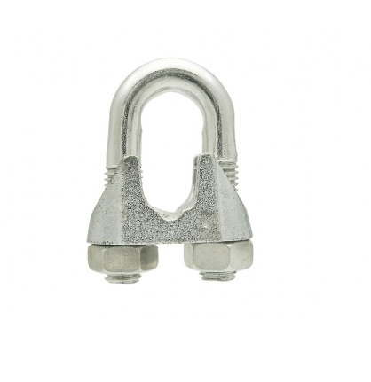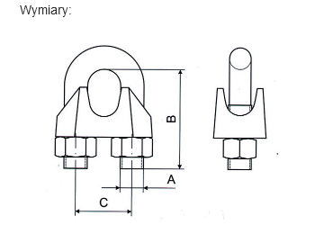

| **A** | **B** | **C** |
| --- | --- | --- |
| 5mm | 19mm | 11mm |